**VISVESVARAYA TECHNOLOGICAL UNIVERSITY**

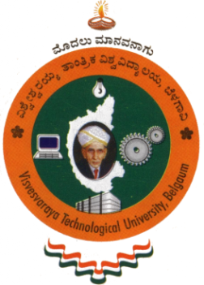**“Jnana Sangama”, Belagavi – 590 018**

A

Mini Project Report

on

**“Criminal Database Management”**

*Submitted in partial fulfillment of the requirement for the DBMS Laboratory with miniproject(18CSL58) of V Semester*

**Bachelor of Engineering**

in

**Computer Science and Engineering**

*Submitted By*

**Arpit Choudhary**

**[1GA18CS030]**

Under the Guidance of

**Mrs.Vanishree M L**

Assistant Professor, Dept. of CSE





**Department of Computer Science and Engineering**

**GLOBAL ACADEMY OF TECHNOLOGY**

**Rajarajeshwarinagar, Bengaluru - 560 098**

**2020 – 2021**

**GLOBAL ACADEMY OF TECHNOLOGY**

**Department of Computer Science and Engineering**



**CERTIFICATE**

Certified that the V Semester Mini Project in DBMS Laboratory with mini project Entitled **“Criminal Database Management”** carried out by **Mr. Arpit Choudhary**, bearing **USN 1GA18CS030** a bonafide student of Global Academy of Technology, in partial fulfillment for the award of the **BACHELOR OF ENGINEERING** in Computer Science and Engineering from **Visvesvaraya Technological University, Belagavi** during the year 2020-2021. It is certified that all the corrections/suggestions indicated for Internal Assessment have been incorporated in the report submitted in the Department Library. The DBMS Mini Project report has been approved as it satisfies the academic requirements in respect of the miniproject work prescribed for the said Degree.



Dr. Srikanta Murthy K

Professor & HOD

Dept. of CSE

GAT, Bengaluru.

Mrs. Vanishree M L

Assistant Professor

Dept. of CSE

GAT, Bengaluru.

Name of the Examiners Signature with date

1.

2.